Bug Report

1. **Title: User is able to delete record marked with label ‘You’**

**Description**: According to specification, the user should be restricted from deleting the record marked as "You". However, upon trying to delete this specific record, the system allows its deletion instead of restricting the operation or displaying an error message.

**Severity**: Critical

**Steps to reproduce**:

Navigate to “http://localhost:3000”.

Locate the record labeled as "You".

Click on the 'Delete' button associated with the "You" record.

**Expected Result:**

The record marked as "You" should either not display a 'Delete' button or, upon attempting to delete, an error message should pop up indicating that the 'You' record cannot be deleted.

**Actual Result**:

The record marked as "You" can be deleted after clicking the 'Delete' button

**Screenshots:**

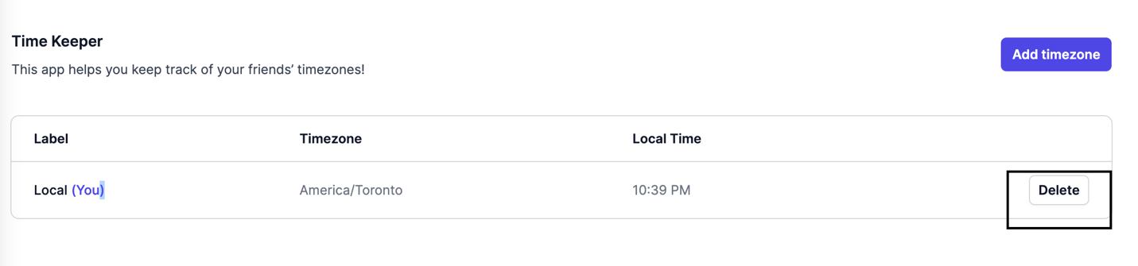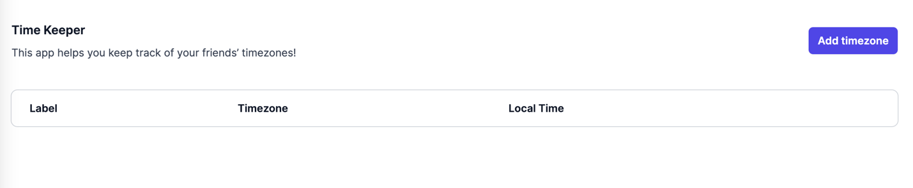

Assigned to: [Name of developer or team responsible for this feature]

Reported by: [Your Name]

Date Reported: 14th October 2023

Status: Open/New

1. **Title: Incorrect sorting order for 'Local Time' column in Time keeper table**

**Description**: According to specification, the table is expected to sort time entries such that the earliest 'Local Time' appears first and the latest 'Local Time' appears last. However, the current behavior is not sorting the 'Local Time' column in the correct order.

**Severity**: High

**Steps to reproduce:**

Navigate to “http://localhost:3000”.

Add multiple timezones to the table.

Observe the sorting order of the 'Local Time' column.

**Expected Result:**

The 'Local Time' column should be sorted in ascending order, with the earliest time listed first and the latest time listed last.

**Actual Result:**

The 'Local Time' column is not sorted in the expected order. The earliest time isn't listed first and the latest time isn't listed last.

**Screenshots:**

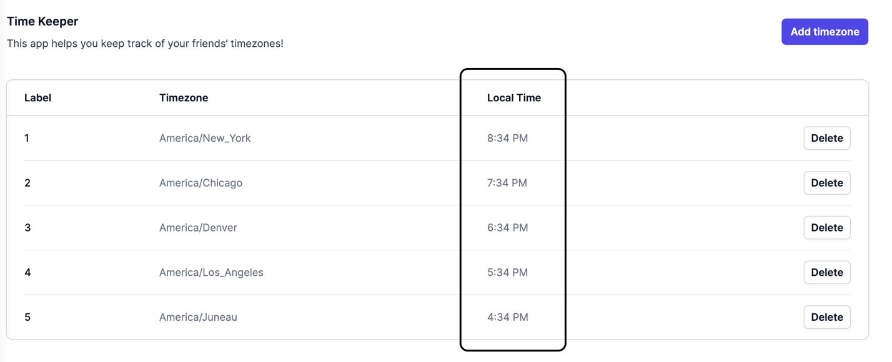

Assigned to: [Name of developer or team responsible for this feature]

Reported by: [Your Name]

Date Reported: 14th October 2023

Status: Open/New

1. **Title: Error popup displayed upon refreshing the website**

Description: When navigating to the website and refreshing the page, an error popup appears in the left bottom corner. Clicking on this popup reveals three unhandled errors with details.

**Severity**: High

**Steps to reproduce**:

Navigate to “http://localhost:3000”.

Refresh the page.

Observe an error popup appearing on the left bottom corner.

Click on the error popup.

**Expected Result**:

The page should refresh smoothly without any error popups or unhandled errors being shown to the user.

**Actual Result:**

An error popup is displayed on the left bottom corner of the page. Upon clicking the popup, it reveals three unhandled errors with their respective details.

**Screenshots**:

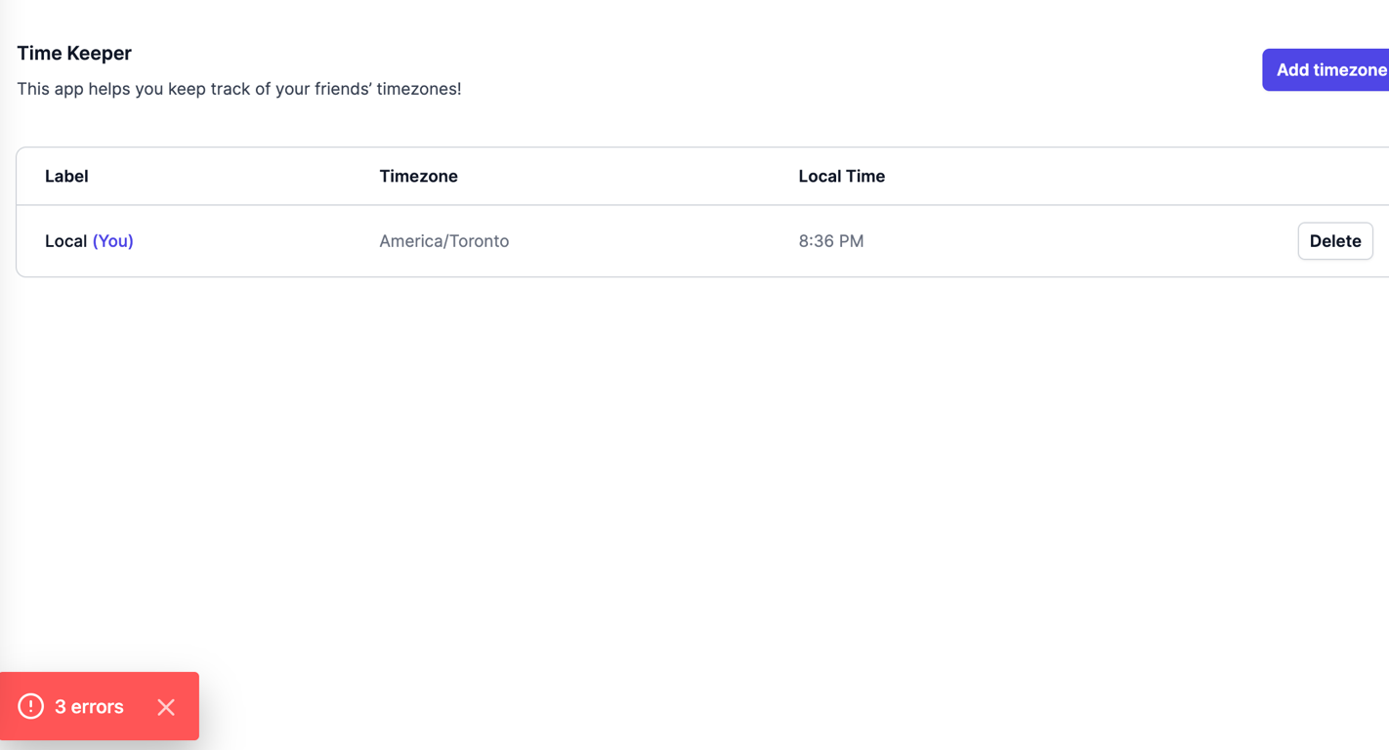

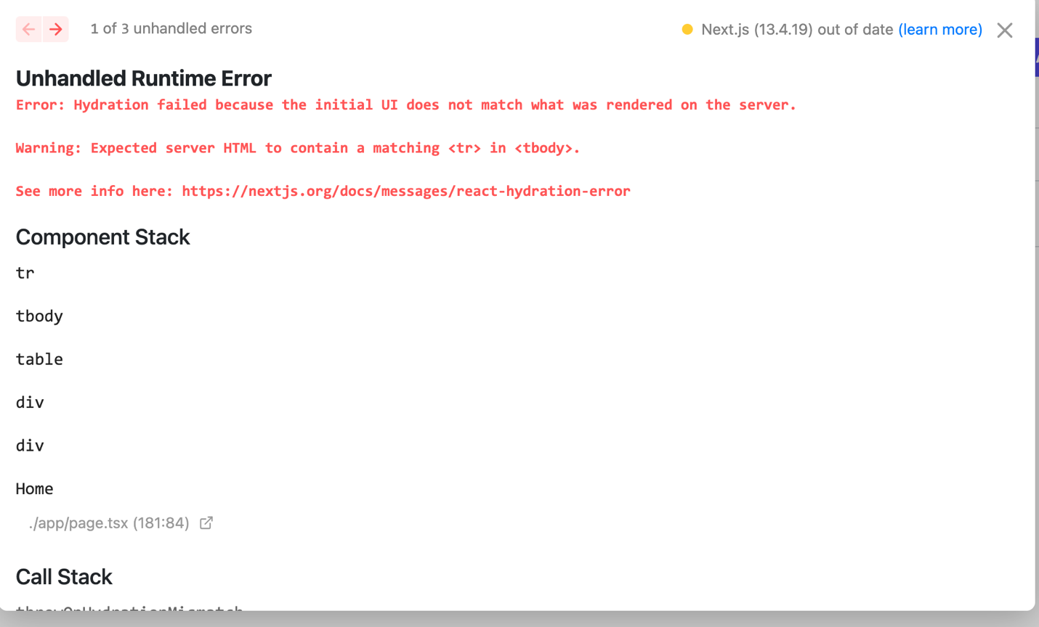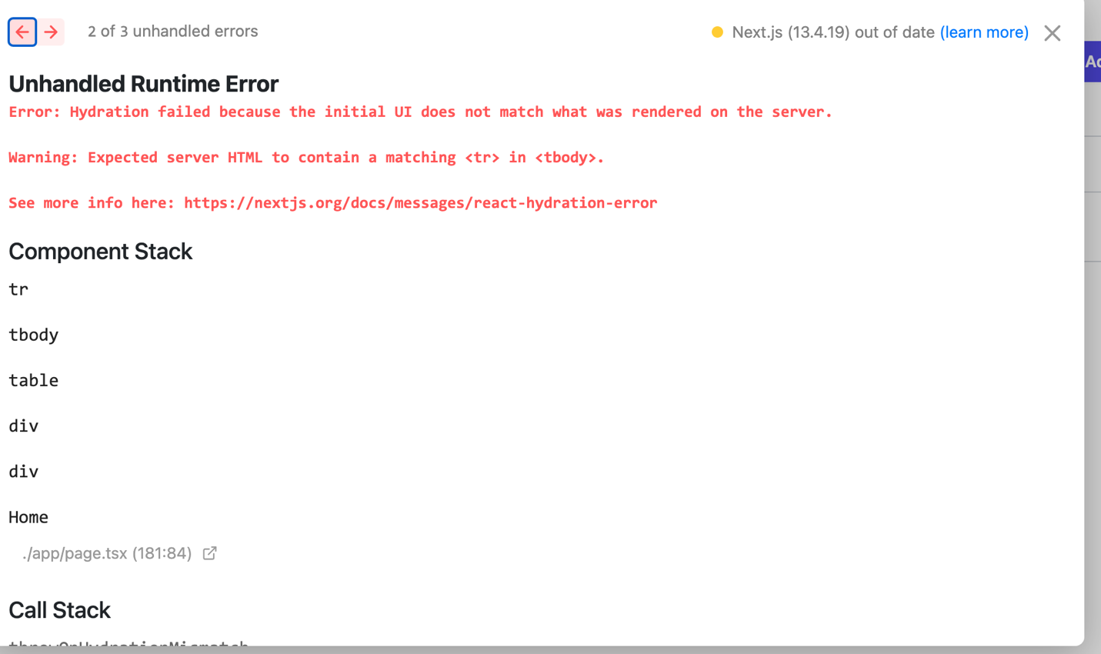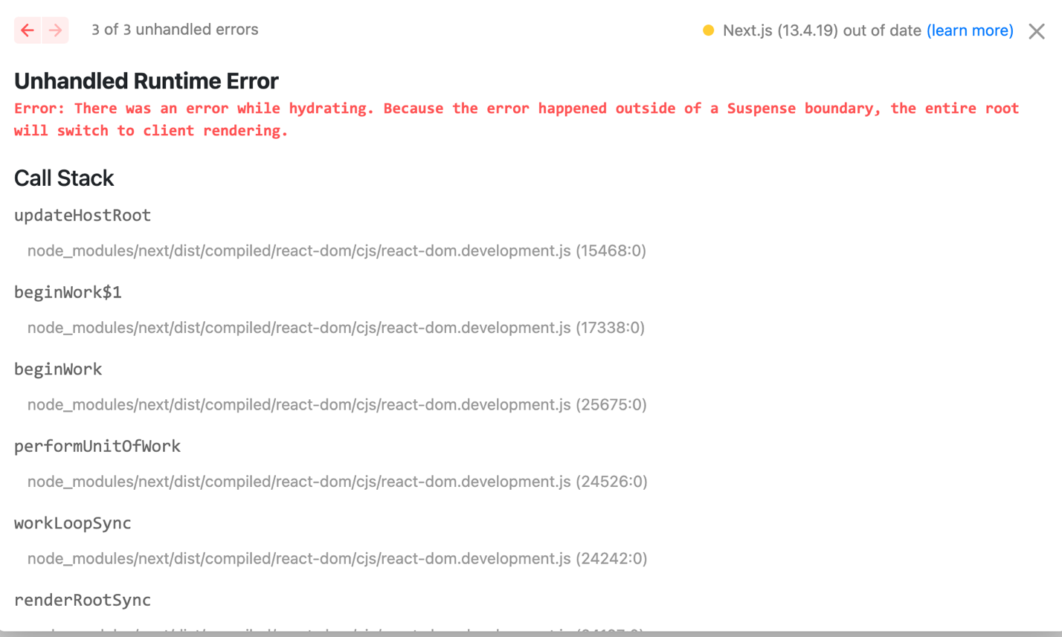

Assigned to: [Name of developer or team responsible for this feature]

Reported by: [Your Name]

Date Reported: 14th October 2023

Status: Open/New